Human Resource (HR) Data Structure

Last Updated: April 20, 2020

Summary

The purpose of this document is to define the YourCause standard for the HR file integration and to capture relevant client data for field mapping.

This document explains the file transfer process, the formatting and field requirements of the file, and the reasons for HR file load failures. It can answer most questions about the YourCause HR file integration process. Further technical specifications can be found on the HR Specifications and Validation Requirements document.

**Table of Contents**

Summary and Introduction 1

Human Resource (HR) Files 3

File Transfer 3

SFTP Transfer 4

Environments 4

File Specifications 5

File Naming Convention 5

Format 5

Frequen cy and Schedule 5

Employee Populations 5

Assigning User Profiles 6

Required Fields 7

Conditional fields 8

Custom field s 9

Common Failures 9

Next Steps 10

# Human Resource (HR) Files

The HR file is the full demographic file that is used to populate user records within YourCause’s platform. Ongoing updates of the HR record will serve as the determinate for who can/cannot access the system. The HR file must contain, at minimum, a single unique identifier per eligible employee that can be used to associate other related data necessary when using the platform.

*The HR file contains the unique identifiers as are required to validate the user during the (SAML 2.0) authentication process.*

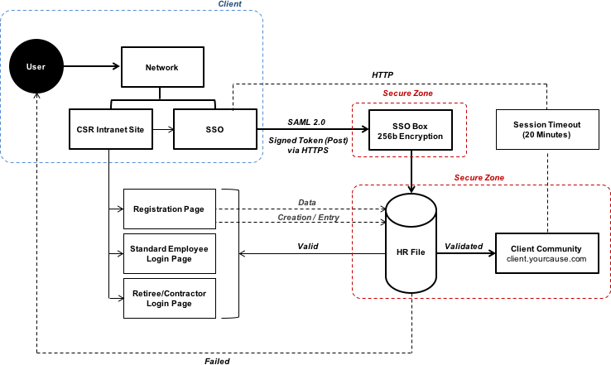

File Transfer

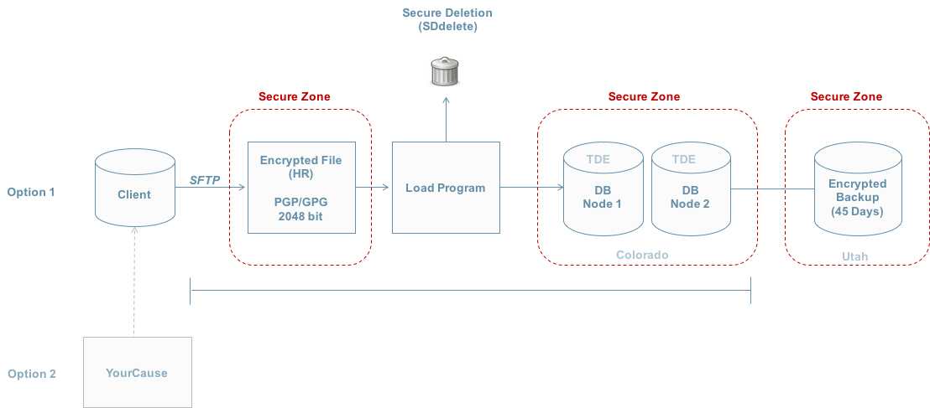

## SFTP Transfer

* The HR file will be transferred via SFTP with PGP encryption.
* YourCause will provide the SFTP unless the client chooses to provide their own.
  + YourCause will also provide public encryption keys.
* The SFTP credentials and file transfer frequency details are captured in HR Specifications and Validation document.

## Environments

* YourCause will load files into two environments: UAT and Production.
  + A test file will be expected to be loaded by the client to the UAT username on the SFTP during the HR testing period.
  + This file should contain actual data for testers that includes all relevant data needed for testing scenarios (ex: matching, payroll, and/or segmentation details), and (if applicable) actual data for users associated with records in historical data import files.
* A file containing live data and matching the exact format of the approved UAT file will be expected to be loaded to the Production username on the SFTP before the platform can be launched to employees.

# File Specifications

## File Naming Convention

* + Below is the required naming convention for the YourCause HR file. All files must use the same naming convention or future loads will fail.
    - *<ClientName>_YourCause_HR_MMDDYYYY.txt*

## Format

* The file should be a full, pipe-delimited text file each time.
  + *YourCause does not process termination codes.*
* The first row must be a header row containing the names of all fields exactly as listed in the YourCause HR Specifications and Validation Requirements Document.
  + Optional fields can be sent with blank values, but the column headers must be included in the file.
* The file must not contain a footer.
* There are character limits for each field included in the HR file, as indicated in the HR Specifications and Validation Requirements Document.

## Frequency and Schedule

* YourCause recommends that all HR files be uploaded to the SFTP weekly.
* YourCause will load the HR file outside of regular business hours.
  + The client may choose the time that the file will be delivered and YourCause will schedule the load of the file accordingly.
  + The day and time of the load will be communicated once confirmed by the YourCause data team.

## Employee Populations

* Any user who should have the ability to access the YourCause system must be included on the HR file.
* Non-general employee populations (e.g. retirees or contractors)
  + If a user is not included on the HR file, they will not be able to access the system unless other arrangements have been made during the Sales process.

## Assigning User Profiles

* **New users –** the YourCause HR file load process checks for the unique identifier. If the unique identifier for a user record does not already exist in the system, a new user profile will be created for that identifier.
* **Existing users** – if the unique identifier for a user record already exists in the system, the data in the other HR fields for that record will be updated with the values provided in the HR file.
* **Users removed** – if a unique identifier for an active employee profile is not found on the HR file, the HR load program will deactivate that user profile.
  + When a profile is deactivated, it is not deleted. The user’s history and data are still

retained in the system and will display in reports.

* + If the unique identifier for the deactivated user profile is included in a future HR file, the HR load program will reactivate the user’s original profile and will restore the user’s data and history.

## Required Fields

#### *First name*

#### *Last name*

* \****Email address***\* – required for system generated emails
  + *Can be left blank if an email is not available for a user, but YourCause strongly recommends that the email be included.*
* \****Unique Employee ID***\* – the values in this field must be unique and non-changing.
  + As mentioned above, this will be used to identify specific user profiles.
  + If a user’s unique identifier changes, the new identifier will be treated as a new record in

the YourCause system.

* \****SSO ID***\* – used as both the SSO identifier and the username users enter in the basic authentication/login flow.
  + The SSO identifier is the value passed as the Name ID claim in the SSO exchange process.
* \****Temporary Password***\* – secondary validation field used in the basic login flow
  + Most clients populate this field with the user’s last name, but any custom value is

allowed besides sensitive data (such as social security number).

* + Customizable text is available to explain to users how to determine the value to enter in this field.
* \****ZipCode***\* – Employee’s work zip code
  + Used as the primary zip code in the system. If another zip code should be considered as the primary zip, it must be mapped to this field.
  + Used to calculate search radius in Volunteering.
* \****WorkCity***\* – Employee work city
  + Used to calculate search radius in Volunteering.
* \****WorkState***\* – Employee work state
  + Used to calculate search radius in Volunteering.
* \****Country***\* – two-digit ISO code for each user’s country must be provided, even if all users are in

US.

* \****IsEmployeeActive***\* - used to distinguish active and inactive users in specific situations.
  + A value of 1 can be populated for all users, with the logic to send only active users added to the feed on the Client side.
  + Client should not send terminated users unless agreed upon ahead of time with the

YourCause team, since licensing fees are based on the number of users included in the file.

## Conditional fields

* ***Manager’s Employee ID*** – required if using the hierarchical company report
  + Each user record must include the EmployeeID for the user’s supervisor.
  + Every supervisor must be included on the HR file.
* ***Salary*** – required if using the percentage of salary option in payroll giving
  + This data is excluded from all reporting options, including ad hoc reporting.
  + Salary must be provided in the user’s currency as indicated on the HR file.
* ***Payroll ID*** – required if the user is identified in the client’s payroll system using an ID that is

different from the unique identifier

* ***Pay Currency Code*** – required if the client is using the Payroll feature or international giving
  + Must be sent as a 3-digit currency, such as USD or INR.
  + Default is USD.
* ***Pay Periods*** – required if the Payroll feature is used
  + Numerical value of number of annual pay periods for an employee. (Ex: 12, 24, 26, 52).
  + Default is 24.
* ***Payroll Filter*** - used to segment payroll
  + Consult with your Implementation Manager or Account Manager to determine the values for this column.
  + Each payroll file sent will require a separate value for this field.
    - Ex: US employees only should have payroll, so they should have a US value in this column. Or if Company 1 and Company 2 are handled by separate payroll teams, send the value for Company 1 or Company 2 in this field.
* ***Match Filter*** - used to segment matching
  + Consult with your Implementation Manager or Account Manager to determine the values for this column.
  + Each population that has its own match program/match cap will need its own value in this column, with the exception of users in different currencies.
* ***Custom Segment*** - used to segment users.
  + Consult with your Implementation Manager or Account Manager to determine the values for this column.
  + Each segment should have its own value here.
    - Ex: retirees and regular employees, or population that should see giving and population that should not see giving, or Region 1 and Region 2 and Region 3 which have differently branded landing pages.

## Custom fields

* If a field is not listed in the HR template document, it is considered a custom field in the YourCause system.
* A total of thirteen custom fields can be included (or only twelve if the client sends a value in the PayrollFilter field)
* Headers must match the custom field headers listed in the HR template document – we recommend defining these values in the HR Specifications and Validation document.

## Common Failures

### Errors

* + Duplicate emails or employee IDs – the YourCause system cannot accept duplicate emails or employee IDs, since the employee ID is used to identify individual records and the email address is used for contact purposes.
  + Missing key values – if a required field (or non-required field that is being used as a feature filter or for another custom purpose) is blank for a specific user record, the file load will fail.
    - All required and mapped fields must include values for all user records.
  + Number of records – YourCause includes a load threshold of +/- 5% for all HR file loads.
    - If the number of records in the HR file exceeds this threshold, the file load will fail.
    - YourCause must be notified before large numbers of employees are added to or removed from the HR file.
  + Delay in file upload – YourCause schedules file loads to occur at specific times, as determined

with the client during the Implementation process.

* + - If a file is not provided before the required time, the file load will fail.
    - If the client does not provide the HR file at all on a particular week, the file load will fail.
    - YourCause must be notified if a file cannot be provided at the expected time.
  + Unplanned format changes – YourCause expects the HR file in a specific format with specific field requirements.
    - If this format or the fields contained in the file change, the file load will fail.
    - YourCause must be notified before such changes are made.

### Handling errors

* + In the event of an HR file load failure, the YourCause data team will be notified immediately via email. The YourCause data team will then reach out to the YourCause Account Manager assigned to the client account, who will connect with the appropriate client contact(s) with the next steps for the resolution of the issue.

# Next Steps

Complete the checklist and the columns highlighted in yellow in the HR Specifications and Validation Requirements document.

Your team will return the completed documents to your YourCause contact and upload a test version of the HR file to the SFTP.

YourCause will write the HR load program in UAT and will load the data into the YourCause UAT environment per the deadlines listed in the project plan.

Additional Questions?

Please reach out to the Implementation Manager at YourCause who provided this documentation, or otherwise your main point of contact at YourCause.