Payroll Implementation
Last Updated: Feb 6, 2020

Summary and Introduction
The purpose of this document is to clearly define the standards set forth by YourCause, for the exchange of the payroll file and to gather relevant client data for file integration.

The first section of this document explains the process used for handling file transfers, the types of files used, and the formatting requirements for each file. This section answers questions pertaining to the payroll file exchange process currently utilized by YourCause with each client.

The second section details the standard field layouts of YourCause payroll files.

The third section includes a checklist that captures client information necessary for the configuration of the payroll deduction process. YourCause requests that all onboarding clients complete this checklist prior to the start of the implementation.

Please read the first section carefully. Verify that your team can accommodate the YourCause standard fields listed in the second section and proceed to complete the implementation checklist in the third section.
Table of Contents
Summary and Introduction 2
Payroll Files 3
File Types 4
Full File vs Delta File 4
File Naming Convention 5
File Format 5
Frequency and Schedule 5
Employee Pay Schedules 5
Funding 6
File Schema 7
Implementation Checklist 9
Additional Questions? 12

Payroll Files
Payroll processing for a particular cycle involves the exchange of multiple files between the client’s payroll system and the YourCause system. This document outlines some general guidelines for implementing these interfaces.
The following flowchart shows how the payroll file is used between YourCause and each client to perform the contracted services and the role each party plays in the process.

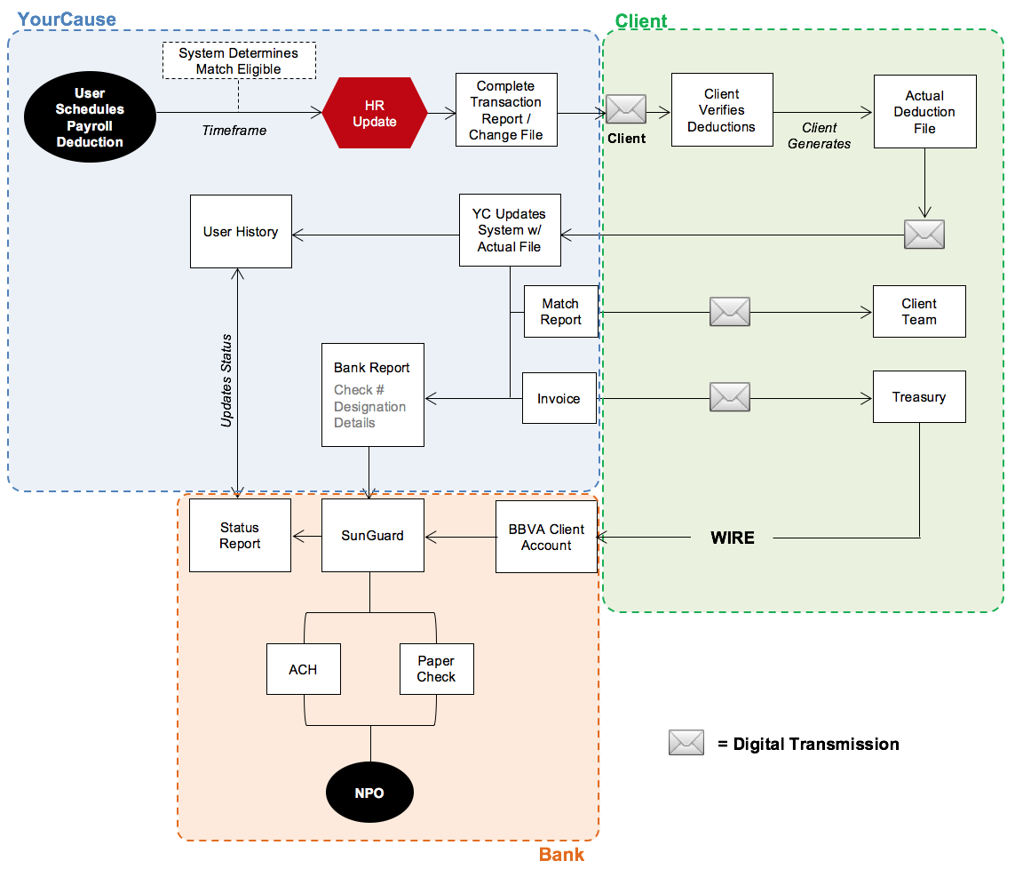

File Types
- Payroll Deduction file (YourCause to Client)
This file outlines the amounts requested by employees (using CSRConnect) to be deducted from their payroll. These will either be the initial requests submitted during the creation of the payroll deduction, or a change in the deduction requested by the employees using the application. This file will contain a unique employee identifier from the HR file, the donation amount, and the frequency.
Note: going from a one-time deduction to no deduction does not count as a change. The one-time deduction will only appear on one change file, then will not appear on subsequent files. There will be no zero-out of the amount.

- Payroll Actual file (Client to YourCause)
This file outlines what the client actually deducted for each employee for that pay period. This file contains a unique employee identifier from the HR file, the donation amount, and other optional fields (details included in the File Schema section of this document).

Full File vs Delta File
- Full File
  - Contains all active recurring deductions aggregated by each employee. One sum total record will be included for each employee.
  - Contains all recent one-time deductions (not sent on a previous full file) aggregated by each employee. One sum total record will be included for each employee.
  - Does not contain zero-outs for recurring deductions that have ended recently.

- Delta File
  - Contains all active recurring deductions aggregated by each employee if that total has changed from previous file. One sum total record will be included for each employee for each frequency (one-time or recurring).
  - If any change is made to the employee’s total payroll deduction amount (including one-time and recurring donation amounts), both one-time and recurring amounts will be added to the change file (even if one of the amounts has not changed).
  - Contains all recent one-time deductions (not sent on a previous full file) aggregated by each employee. One sum total record will be included for each employee.
  - Will include zero-outs for recurring deductions if all recurring deductions have been ended and the employee’s sum deduction total has reached zero.
  - Does not include zero-outs for one-time deductions sent on previous files.
YourCause suggests that clients implement a full payroll deduction file solution. This approach ensures that the client payroll system and the YourCause system are always in sync.

The delta file approach requires that YourCause predict which payroll deduction schedules are active in the client’s system. Over the course of time, missed processing of deduction files or manual deactivation of deductions in the client payroll system causes these systems to go out of sync, which leads to reconciliation issues.

File Naming Convention
Below are required naming conventions for deduction and actual files. In the event that multiple files will be used, the ClientName should be appended with a qualifier. (Ex: ClientNameUS or ClientNameCA)

- Payroll Deduction File
<Clientname>_YourCause_Deductions_MMDDYYYY.txt

- Payroll Actual File
<Clientname>_YourCause_Actuals_MMDDYYYY.txt

File Format
Below are the formatting requirements for payroll files:
- Actual and deduction files should be pipe-delimited text files.
- Each file should contain a header row with column names.
- All rows in the file need to have carriage return and a line feed to mark the end of each line.
- The schemas listed below represent the YourCause standard format. Deviating from this format could incur an hourly fee for custom work.

Frequency and Schedule
- The frequency of deduction files may be determined by program parameters and the pay frequencies of different employee groups. YourCause requests that for recurring deduction files – those required more frequently than on an annual basis – the files are scheduled for upload to the SFTP on the same day on a regular schedule. Example – Tuesdays, bi-weekly.
- If a deduction file is scheduled by a certain time for client’s payroll team to load, YourCause will also recommend the file be delivered to the SFTP by end of day the business day before. Example – a file due by 10:00am EST on Wednesdays will be uploaded by EOD the Tuesday before.
- If a deduction file is scheduled to be delivered on a holiday or a day the YourCause offices are closed, the file will be delivered the business day before.

Employee Pay Schedules
- YourCause does not split files up based on user pay schedules by default. All users would be included in a deduction file regardless of the user’s number of pay periods.
- YourCause recommends that deduction files be sent on the most frequent pay schedule, then the client schedules the deductions internally for the less frequent pay schedules.
  - For example: If users of both biweekly and weekly pay schedules are included on a file, the file would be sent weekly. The client would check against HR data to verify which users are not paid weekly and would ignore the amount sent on every other file for those users or would otherwise use the files to schedule the dates of the deductions.
- If the above cannot be accomplished, the second option is to contract for multiple deduction files. The users would be split into multiple payroll programs based on a value included in the PayrollFilter field on the HR file. This value should be correlated to the number of pay periods for the user per year.
  - This option would incur an additional annual fee. Pricing would need to be determined separately.

Funding
YourCause requires that the client provide funds based on the invoice generated after the client provides the actual deduction file. YourCause will not accept prefunding based on the deduction totals in the actual file.

YourCause Testing Standard

The YourCause testing standard for payroll files is as follows. The project plan will provide exact timing for each of the below steps:

- An HR file containing records that the payroll team can validate against will be loaded into the UAT environment.
- The YourCause team will apply the PayrollFilter value(s) to the payroll program(s) if applicable.
- The client payroll and/or business team will impersonate employees in UAT (or request that users log in directly) and add test payroll deductions.
- Once the deductions are added, the YourCause team will sprint the task to generate the test deduction file(s) in the YourCause standard specifications.
- Once the test deduction file task is complete, the file(s) will be transferred to the SFTP and the client will be notified.
- The client will load the test deduction file(s) into the client’s test/stage environment and validate the data and file format and provide feedback or signoff. (If client is not able to load the file, client will manually review and provide feedback or signoff on the data and format.)
- Client will return test actuals file(s) to YourCause via SFTP.
- Once provided, YourCause will sprint the review of the test actuals file(s).
- YourCause will review the test actuals file(s) and provide feedback or signoff.
- Once signoff is provided for the test deductions file(s) and test actuals file(s), YourCause will sprint the task to move the payroll file code to Production and will provide relevant info to the YourCause Processing Manager assigned to the client’s account.
- Once YourCause moves the code to Production, the Processing Manager will take over and generate the first Production-level deduction file on the date for the first file, captured in the checklist below.
- * Important notes:
  - The YourCause testing standard allows for only one round of payroll testing with one round of HR data. YourCause works in a data sprint process, so the project plan must be adjusted if more than one round of testing will be required. If further rounds of testing will be required by the client (which could include multiple test HR file loads and that multiple test deduction files be generated), the client must notify the YourCause contact as soon as possible before providing project plan signoff so that there will not be a risk of missing the launch date.
  - YourCause will not perform testing in the Production environment. All testing must be performed in the UAT environment.
  - Payroll files cannot be regenerated from the Production environment. There are safeguards in place to prevent duplicate deductions from being added to deduction files.

File Schema
- Payroll Deduction File (inbound to Client from YourCause)
Data Field | Data Type | Required | Values | Comment
EmployeeID | Text | Yes |  | This ID will be the same as the unique identifier provided on the HR file to YourCause.  *In some cases this is the unique identifier in the payroll system, which is not the same as Employee ID. In this scenario, the Payroll ID needs to be provided in the HR file.
FirstName | Text | Yes |  | This value will be the same as what is provided on the HR file to YourCause.
LastName | Text | Yes |  | This value will be the same as what is provided on the HR file to YourCause.
Frequency | Char(1) | Yes | R - Recurring  O - Onetime
DeductionAmount | Currency | Yes |  | For full files, there will not be a zero amount record for recurring deductions in case of deactivation of pledges.  For delta files, there will be a zero amount record for recurring deductions in case of deactivation of pledges.  One-time deductions will not be followed up with zero amount record in subsequent files.

- Payroll Actual File (outbound to YourCause from Client)
Data Field | Data Type | Required | Values | Comment
EmployeeID | Text | Yes |  | This ID will be the same as the unique identifier provided on the HR file to YourCause.  *In some cases this is the unique identifier in the payroll system, which is not the same as Employee ID. In this scenario, the Payroll ID needs to be provided in the HR file.
FirstName | Text | Yes |  | This value will be the same as what is provided on the HR file to YourCause.
LastName | Text | Yes |  | This value will be the same as what is provided on the HR file to YourCause.
Frequency | Char(1) | No* | R - Recurring  O - Onetime | *The header must be provided, but the client is able to send blank values if this cannot be populated.
DeductionDate | DATE(MM/DD/YYYY) | Yes |  | Date the actual deduction will occur in the payroll system.
DeductionAmount | Currency | Yes
DeductionCurrency | CHAR(3) | Yes

Implementation Checklist (must be completed to begin implementation)
Question | Response | Additional Information
Payroll Settings
Will payroll pledges be scheduled during a Campaign only? | ☐Yes ☒No
Are the users allowed to make changes to their payroll pledges throughout the year? | ☒Yes ☐ No
What pay frequencies are used? | ☒52 ☒ 26  ☐24 ☐ 12 ☐ Other
When do these payroll deductions become active after a pledge is created? | ☒Immediately  ☐Start of calendar year  ☐Other (please specify)
When are deductions actually taken from paychecks after the change file is sent? | ☐Immediately  ☐Start of calendar year  ☐Other (please specify)
Are there any users who should not have payroll deductions? | ☐Yes ☐ No | If yes, please specify which HR columns can be used to segment these employee groups in this box.
Can a payroll calendar be provided yearly? | ☒Yes ☐ No | If yes, please send us a copy of the current payroll calendar.
Has the client had a payroll deduction program prior to using the YourCause platform? | ☐Yes ☐ No | A group – tag tools.
If yes to the above, have the deductions from the previous system been canceled and employees are expected to reenter the deductions in the new system? | ☐Yes ☐ No
If no to the above, please describe the plan of action for a blackout period and/or communications/refunds to employees for deductions that are not able to be brought into the YourCause system. |  | This is only an option if client is contracted for a historical pledge import. There may be exceptions found due to charity or employee ineligibility in the YourCause system, in which case a plan will need to be determined for reconciling the discrepancies.
Payroll Deduction Files (the files inbound to the client from YourCause. Refer to payroll files section for more details.)
Is there a need to generate multiple deduction files*?  *Applicable when client has multiple payroll systems or when pay frequencies must be sent on separate files. Incurs an additional fee to add multiple files. | ☐Yes ☒ No | If yes, please specify which HR columns can be used to segment these employee groups in this box.
Will the deduction file(s) be full each time or delta? | ☐ Full  ☒ Delta | YourCause prefers to send a full file each time.
For delta files only, will a blank file be required if there are no changes? | ☐ Yes  ☐ No  ☐ N/A
What is the format of the deduction file(s)? | ☒YourCause standard  ☐ Custom | The YourCause standard includes the fields, format, and naming convention listed above. Any custom format that deviates from the YourCause standard will require review and approval by the YourCause team and will incur a customization fee.
Do you require that the deduction file(s) be encrypted? | ☒Yes  ☐No | If yes, please provide your public PGP keys for test/stage and Production to your YC contact when you return this document. You are welcome to attach the files in this document as well.
What date is/are the first deduction file(s) required? | Friday
What is the requested frequency of deduction files provided by YourCause to the client? | ☒Weekly  ☐Monthly  ☐Bi-weekly  ☐Semi-monthly  ☐Annually | This may be determined by pay frequencies of different employee groups. If recurring files are sent, YourCause requests they be sent on the same day.
What is the requested schedule for delivery of the deduction file(s)? (A payroll calendar can be provided separately, if it clearly indicates the delivery dates for files in order for a deduction to be taken for a particular pay date.) | If annual – Before Jan 1st. | YourCause manually provides the deduction files to the SFTP, so files will be sent on business days during work hours. In the event that the file deadline falls on a holiday, YourCause will provide the file on the business day preceding. (Ex: Weekly on Mondays, biweekly on Tuesday starting the second Tuesday of the month, on the 15th of each month or the business day preceding)
Please provide the naming convention for the deduction file(s). If multiple files are used, please list names of all applicable files. | ClientName_YourCause_Deductions_MMDDYYYY.txt | The YourCause standard must be used. Otherwise the format will be considered custom, and will incur a customization fee as mentioned above.
Is a blank deductions file required if no changes are present? | ☒Yes ☐ No
Will client's payroll system zero out deductions at the end of the year?  *Applicable for Campaign clients only | ☐Yes ☐ No ☒ N/A
Will client require a zero-out file at the end of the year? | ☐Yes ☒ No | At the end of the year, a file with all the employees and a 0 in the file.
Will we generate a full file each year for the next year's deductions?  *Applicable for Campaign clients only | ☐Yes ☐ No ☒ N/A
SFTP host for the deductions file(s): | ☒YourCause SFTP ☐ Client SFTP
If Client SFTP will be used, please indicate the following: | Endpoint / Host name:  Username for UAT:  Username for Prod:  Protocol:  Port:  File path:  IP addresses for exceptions in UAT (if applicable):  IP addresses for exceptions in Prod (if applicable):  Please provide password via phone.. | YourCause info is as follows: Same as for UAT HR file save the minor exception highlighted.  Endpoint / Host name: ycsecureftp.yourcause.com  Username for UAT:  Username for Prod:  Protocol: SFTP  Port: 22  File path: /Payroll  IP addresses for exceptions in UAT: 216.46.190.59  IP addresses for exceptions in Prod: 216.46.164.90 and 74.63.167.35  Password will be provided via phone.
Payroll Actuals Files (the files outbound to YourCause from the client. Refer to payroll files section for more details.)
Will YourCause receive multiple actuals files per pay cycle? | ☐Yes ☒ No | YourCause prefers to receive a single payroll actuals file per disbursement cycle.
If yes to the above, please describe how the files will be split out.
What is the format for the actuals file(s)? | ☒YourCause standard  ☐Custom | The YourCause standard includes the fields, format, and naming convention listed above. Any custom format that deviates from the YourCause standard will require review and approval by the YourCause team and will incur a customization fee.
Do you require that the actuals file(s) be encrypted? | ☒Yes  ☐No | If yes, we will use the YourCause standard PGP encryption keys that your YC contact will provide.
What is the anticipated frequency for delivery of the actuals file(s)? | ☐Weekly  ☒Monthly  ☐Bi-weekly  ☐Semi-monthly  ☐Quarterly  ☐Semi-annually  ☐Annually | YourCause recommends one file per disbursement cycle. If more than one file is to be sent, YourCause requests that they be sent on a regular schedule. This info is captured below.
What is the anticipated schedule for delivery of the actuals file(s)? Please include the date and time. (A payroll calendar can be provided separately, if it clearly indicates the delivery dates and times for files based on the pay dates.) | Day/Date:  Time: | Ex: on the first Monday of the following month, on the 15th of each month
Are there cases where off-cycle payroll processing occurs for which an off-cycle payroll actuals file would need to be generated? | ☐Yes  ☒No  ☐N/A | Possibly and end of year off cycle file that Dexko will work with CSM on if needed.
Please provide the naming convention for the actuals file(s). | ClientName_YourCause_Actuals_MMDDYYYY.txt | The YourCause standard must be used. Otherwise the format will be considered custom, and will incur a customization fee as mentioned above.
SFTP host for the actuals file(s): | ☐YourCause SFTP ☐ Client SFTP
If Client SFTP will be used, please indicate the following: | Endpoint / Host name:  Username for UAT:  Username for Prod:  Protocol:  Port:  File path:  IP addresses for exceptions in UAT (if applicable):  IP addresses for exceptions in Prod (if applicable):  Please provide password via phone.. | YourCause info is as follows: Same as UAT HR File save the one highlighted difference.  Endpoint / Host name: ycsecureftp.yourcause.com  Username for UAT:  Username for Prod:  Protocol: SFTP  Port: 22  File path: /Payroll  IP addresses for exceptions in UAT: 216.46.190.59  IP addresses for exceptions in Prod: 216.46.164.90 and 74.63.167.35  Password will be provided via phone.
Payroll Processing
What is the payroll disbursement frequency? | ☒Monthly ☐ Quarterly  ☐Other (please specify) | This is how often YourCause disburses payments to charities.
Is payroll matching used? | ☒Yes  ☐No
If yes to the above, what is the matching disbursement frequency? | ☒Monthly ☐ Quarterly  ☐Other (please specify) | This is how often YourCause disburses payments to charities.
Will a standalone, contracted bank account be used, or will the client use the YourCause commingled account? | ☒Standalone account  ☐Commingled account | This is determined in the SOW.
Will multiple bank accounts be used? | ☐Yes  ☒No | This is non-standard and must be outlined in the SOW or via a change order form.
If yes to the above, please list the names of the accounts and describe what will be funded via each account.
Will a single invoice be provided for each disbursement cycle? | ☒Yes  ☐No | Splitting up invoices will incur a custom invoicing fee, as to be determined in discussion with the YourCause Processing Manager.
If no to the above, please describe how invoices will be split out.
Testing
Will client use the YourCause standard testing timeline as outlined in the YourCause Testing Standard section above? | ☐Yes ☐ No
If no, please describe the requested testing timeline/steps or provide separate documentation. |  | A nonstandard testing timeline will require changes to the project plan at the beginning of the project. Changes to the timeline after project plan signoff may require the launch date to be pushed out.
If a customized testing timeline (as captured above) will be used, will additional UAT HR loads be required outside of the single load included in the YourCause standard project plan? | ☐Yes ☐ No

Additional Questions?
Please email all additional questions related to this document, the processes defined within, and the requirements of the CSRconnect Payroll Implementation process to your assigned YourCause contact(s).

